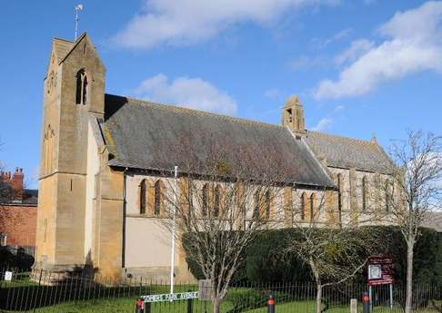
20th June 2022

Seeds for Life Day for Year 4
Dear Parents/Carers
On Wednesday 13th July, Year 4 will be visiting The Church of the Ascension in Somers Park Avenue, to take part in “Seeds for Life”. Seeds for Life aims to support schools in the delivery of Christianity for Key Stage 2. The workshops will be held at the church and in the adjoining gardens. ‘Seeds for Life’ is complementary to ‘Life Path’ and ‘Open the Book’ and is aimed at children in Years 3 and 4; it is suitable for children of all faiths or none. The children will experience an exciting day of learning outside the classroom; during the day the children will have an introduction, followed by drama, storytelling, work in small groups and quiet reflection.

We will leave school at 9am and will return to school before 3.15pm.
Please ensure that your child arrives at school at 8.45am on this day.

There is a small charge of £2 per child for this event; Mrs James will send you a payment link
The children will walk to and from The Church of the Ascension, so will need sensible black school shoes and a raincoat/sun cream depending on the weather.
They will also need to bring a packed lunch and drink. Pupils who normally have school lunches will be provided with a packed lunch.
If you have any further questions please message us via Class Dojo.
Yours sincerely
Mrs Maidens
Class Teacher.

